TIGRES Fundraiser

Please join us at Snapper Jack’s Taco Shack for some delicious food and help us raise funds to benefit the Tigres Track and Field Club.
Please bring this flyer on April 25 and present it to the cashier when ordering. 20% of your check will benefit Tigres.

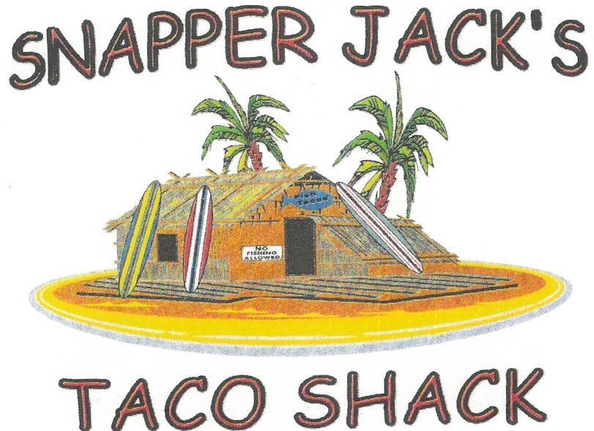

5100 Telegraph Rd. Suite F&G, Ventura, CA 93003
805-642-5111

Wednesday April 25, 2018
11 a.m. – 9 p.m.

Includes Take-out
Thanks for your support. We can’t wait to see you!

